Task 1:
Data binding - is the process of connecting data from the application to the UI (User Interface), so that when the data changes, the UI updates automatically.

Task 2:
One-Way Data Binding - data flows in one direction only. From component to UI, or from UI to component.
Two-Way Data Binding - data flows in both directions. Component updates UI and UI updates component.

Task 3:
One-Way Data Binding
Use when the UI only needs to display data.
Examples:
- Showing bank balance
- Showing customer details
- Showing transaction history
Two-Way Data Binding
Use when the user enters or edits data.
Examples:
- Login form
- Registration form
- Fund transfer form
- Search box

Task 4:
State is an object that stores data of a component. When the state changes, React automatically updates the UI.

Task 5:
SPA stands for Single Page Application. A Single Page Application loads only one HTML page initially. After that, React updates only the required part of the page instead of reloading the entire webpage.

Task 6:
DOM stands for Document Object Model. It is a tree-like structure of an HTML page. JavaScript uses the DOM to read and modify webpage elements.

Task 7:
The Virtual DOM is a lightweight copy of the Real DOM. React first updates the Virtual DOM. Then it compares the old Virtual DOM with the new one. Only the changed parts are updated in the Real DOM.

Task 8:
Props (Properties) - are used to pass data from a parent component to a child component.
Prop drilling - means passing props through multiple intermediate components just to reach a deeply nested component.

Task 9:
Advantages of React:
- Component-based architecture
- Reusable components
- Virtual DOM improves performance
- Fast rendering
- Easy state management
- Easy routing
- Large community support
- Easy integration with REST APIs
- SEO support (with Next.js)

Task 10:
A React application is divided into small reusable pieces called components. Each component performs a specific task.
Advantages
- Reusable
- Easy to maintain
- Easy testing
- Better code organization

Task 11:
The React Component Lifecycle refers to the different stages a component goes through from the time it is created until it is removed from the screen. Lifecycle steps include:
Mounting | - Component is created and displayed.
Updating | - Component re-renders when state or props change.
Unmounting | - Component is removed and cleanup is performed.

Task 12:
Hooks are special functions introduced in React 16.8 that allow functional components to use React features such as state, lifecycle methods, and context.
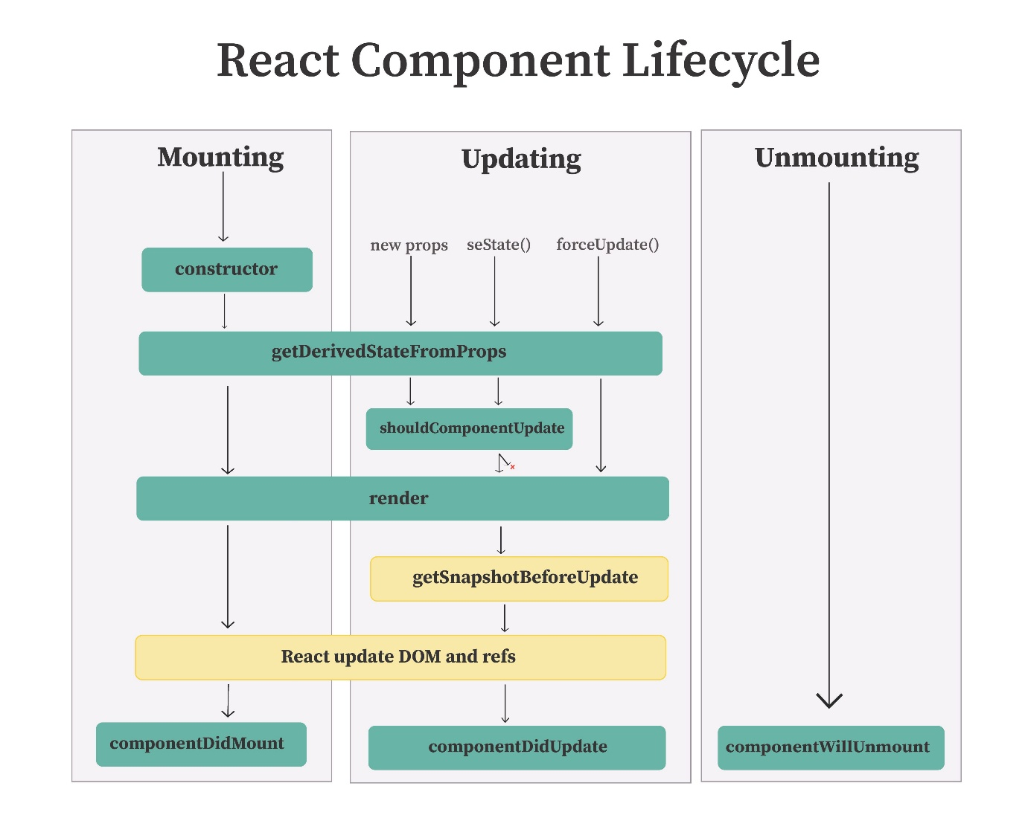

Task 13:
React Redux Architecture is a way of managing shared data in a React application. Redux stores the application's state in a central Store, so all components can access the same data without passing props through multiple components.
Redux Flow:
- User performs an action.
- An Action is dispatched.
- The Reducer processes the action.
- The Store updates the state.
- React components automatically re-render with the updated data.
Main Components:
- Store: Stores application state.
- Action: Describes what happened.
- Dispatch: Sends the action.
- Reducer: Updates the state.
- React Components: Display and use the updated data.
Advantages:
- Centralized state management.
- Avoids prop drilling.
- Easy to maintain and debug.
- Best suited for large React applications.

